

data Visualization using Tableau

Navya Sri, Medidhi (@01413557)



August 8, 2020

|  |  |
| --- | --- |
| **Table of contents:** | **Page no**. 1 |
| Introduction For Each Audience | 2 |
| Visualization tool | 3 |
| Visualizations for each audience | 4 - 10 |
| Order of presentation | 11 |
| Effective Feedback Mechanism | 12 |
| References | 13 |

**Introduction For Each Audience:**

For every audience there is different perspective on the information that is present in the surrounding. For the dataset of “The Vaccine Adverse Event Reporting System (VAERS)”, there are few different stories to convey based on the audience. Those stores and research questions are mentioned below:

For Hospital Management the main concentration is what vaccinations need to be reproduced to get that vaccines with less risk, reduce side effects and get cure for the patients to get that vaccine in time. Because the hospital management just need to know the demand of the medicine based on number of patients need to take the medicine for good health condition.

For healthcare workers interacting with families the main concentration of their story is to educate the patient for future side effects and talking through the facts based on the events reported in past. To enhancing the patient condition and preparing them for future as well.

For the lay public audience are to be aware of what vaccination has highest risk percentage. Because the public just need to be aware of the vaccination that are available for the treatments if at all they need to have them what are the consequences.

**Visualizations Tool:**

To do this visualization I have selected **Tableau tool**. Tableau tool is most powerful, secured, and flexible end to end analytics platform for the data. Tableau is very easy to use interface, this helps the BI industry to analyze data. To visualize data there are few factors that influence the choices, which are audience, content, context, dynamics, and purpose.

**Audience:** It is important to adjust data representation to the target audience. **Content:** the type of data determines the tactics. **Context:** we may use different approaches to the way your graphs look and therefore read depending on the context. **Dynamics:** there are various types of data, and each of it implies a different rate of change. **Purpose:** the goal of data visualization also has serious influence on the way it is implemented.

This tableau creates rich visualizations in just a few seconds, also it performs complex tasks with simple drag and drop functionalities, it handles millions of rows of data without impacting the performance of the dashboards, viewed and operated on several devices like laptops, mobiles and even in tablet, this tableau automatically understands the device that we are using to handle the visualizations and finally while performing basic calculations in tableau itself, for more complicated calculations we get to use R or Python, thus helps us to amplify data with visual analytics.

**Visualizations for each audience:**

**For Hospital Management** the main concentration is what vaccinations need to be reproduced to get that vaccines with less risk, reduce side effects and get cure for the patients to get that vaccine in time. Because the hospital management just need to know the demand of the medicine based on number of patients need to take the medicine for good health condition. To address the selected audience, my analysis of representing data in tree map. The use of this tree map is to display data in nested rectangles. Each rectangle has different size and color. So, I have considered few columns in the dataset to tell the story to the audience that are concentrated in the hospital managements point of view.

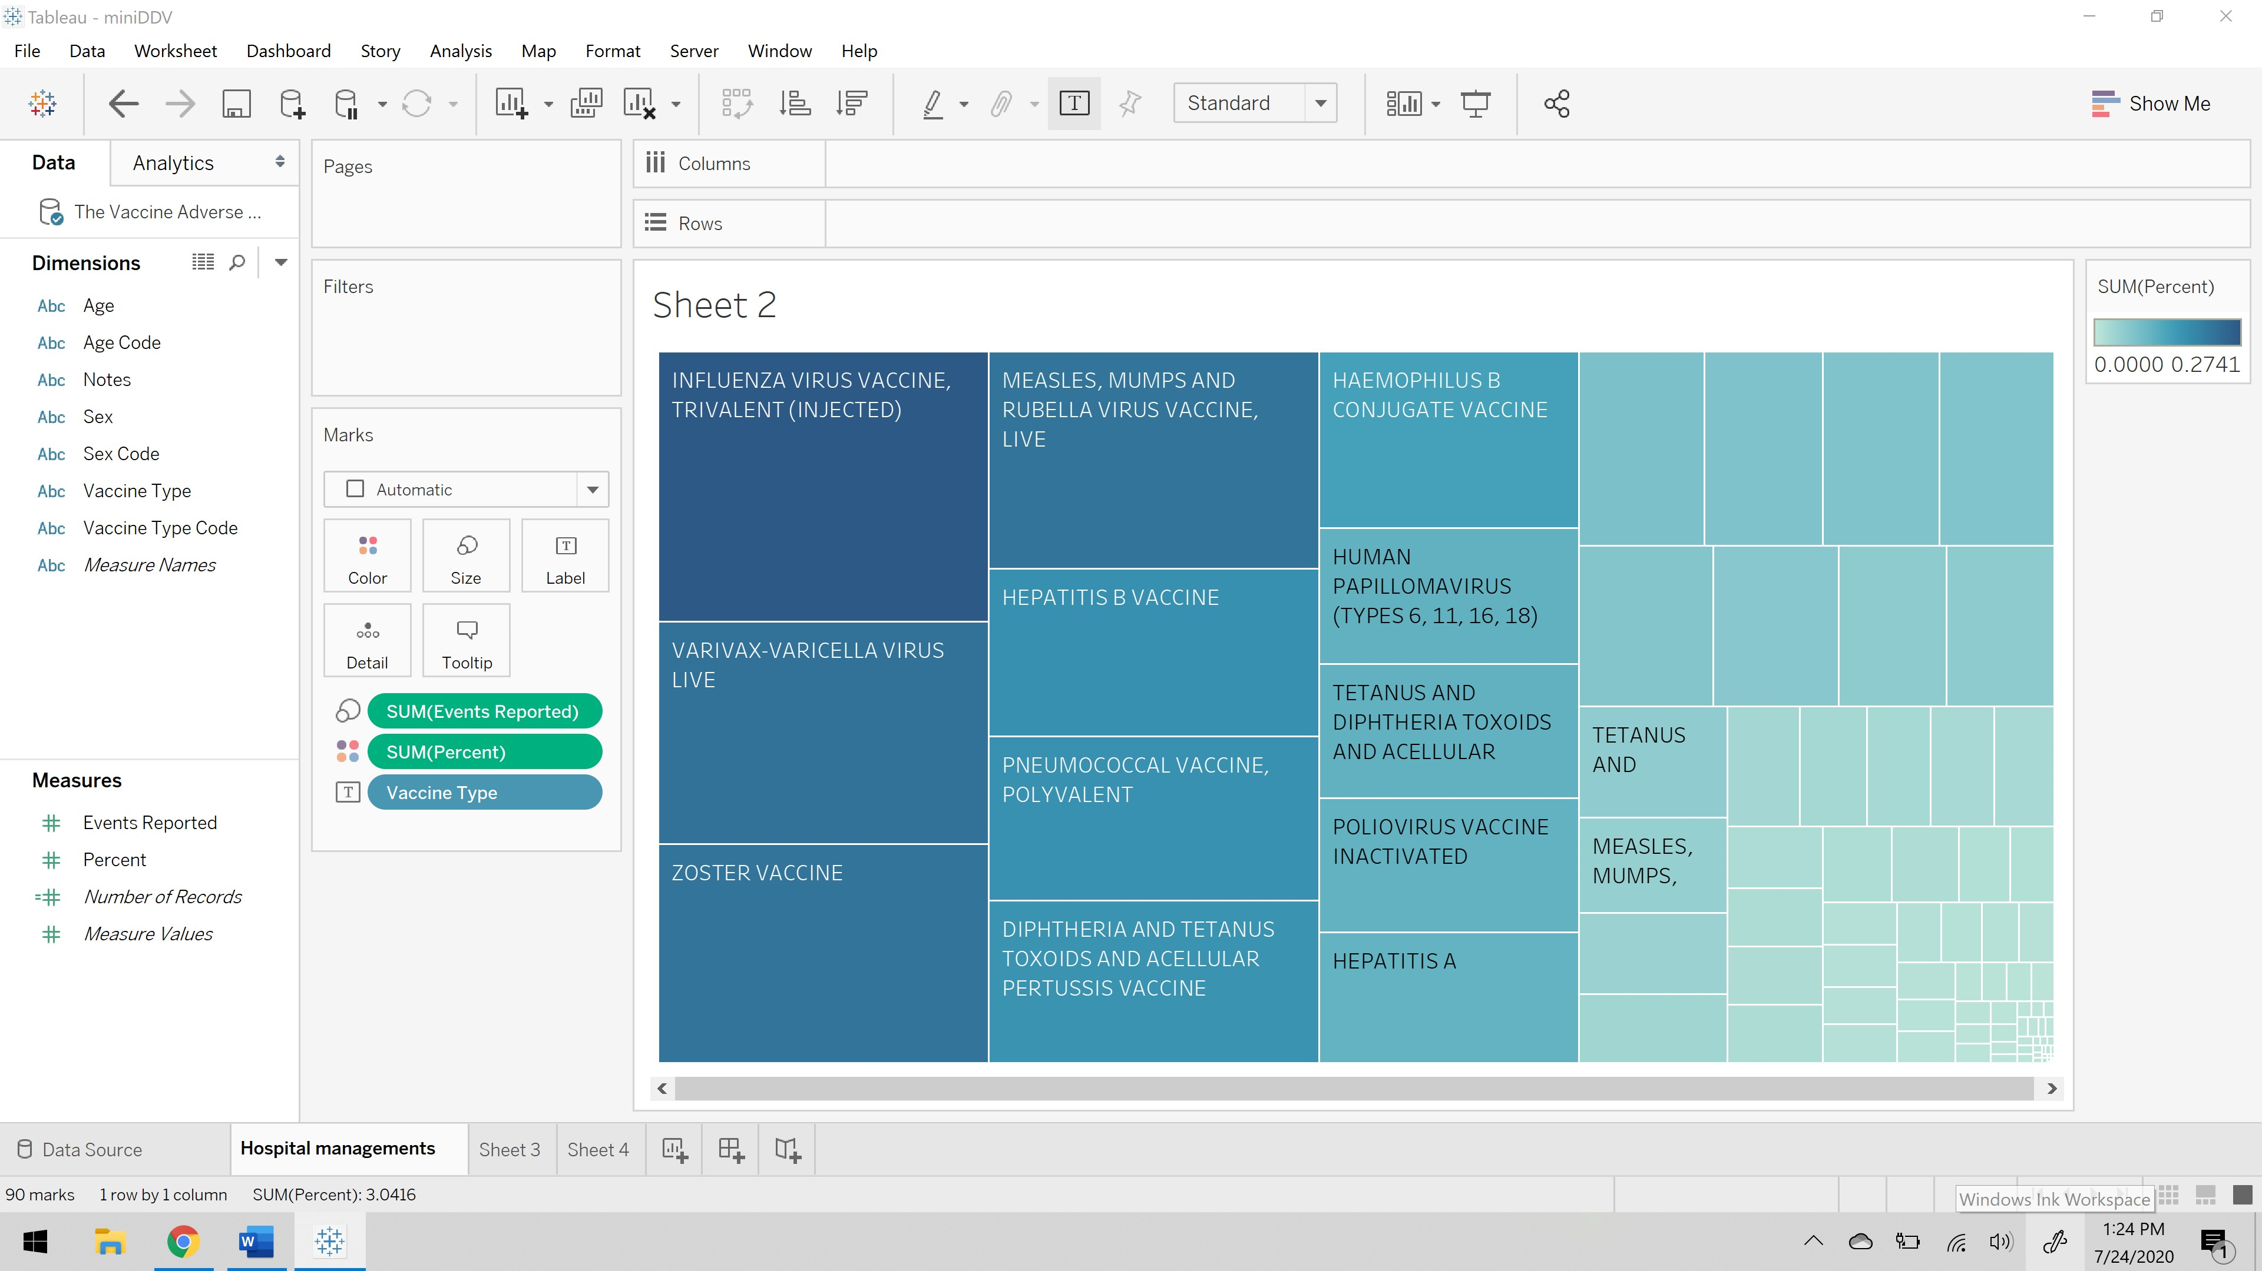

As you can see above visualization vaccines names as been placed on the label as you can see each rectangle is named as you hover on those rectangles. The size of each rectangle is defined by the events reported, which defines the complaints reported by the patients who has taken that vaccines. The color of each rectangle is defined by the percent, which is the risk exposure percentage. So, this visualization states a vaccine should be reconsidered to reduce the risk as per the hospital management’s perspective.

**For hospital management,** I have considered different visualization cues to understand the story in better way. Let us look at the visualization below and understand it. To do this visualization I have taken vaccine type code on to the columns, next on rows I have considered risk percentage and finally I took count of events reported as the variation of color. This tells us about the vaccine which has recorded highest risk percentage and the events reported because of taking that vaccine.

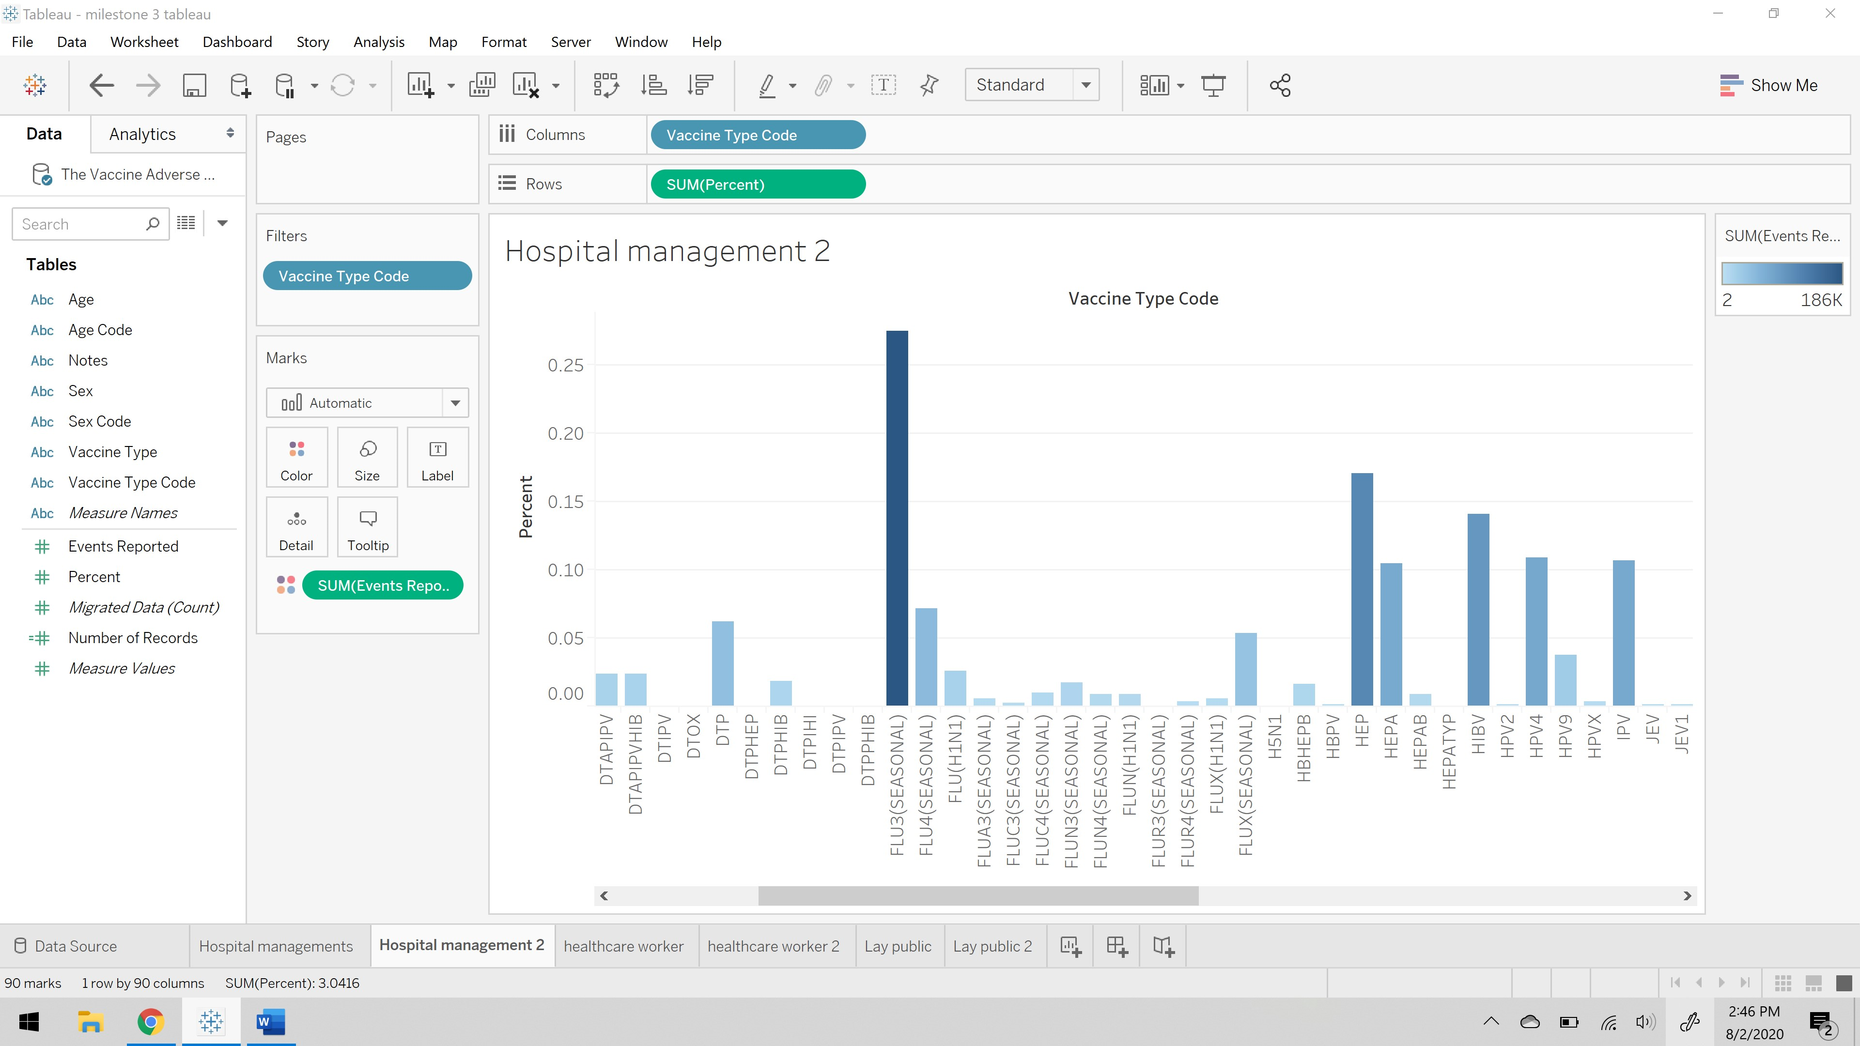

**For hospital management,** I have chosen different visual cues to make the story clear to make the audience understand. Let us understand the visualization presented below. To do this visualization I have considered vaccine type code on color, events reports on the angle, and percent on the label. This tells us about the vaccine which has recorded highest risk percentage and the events reported because of taking that vaccine.

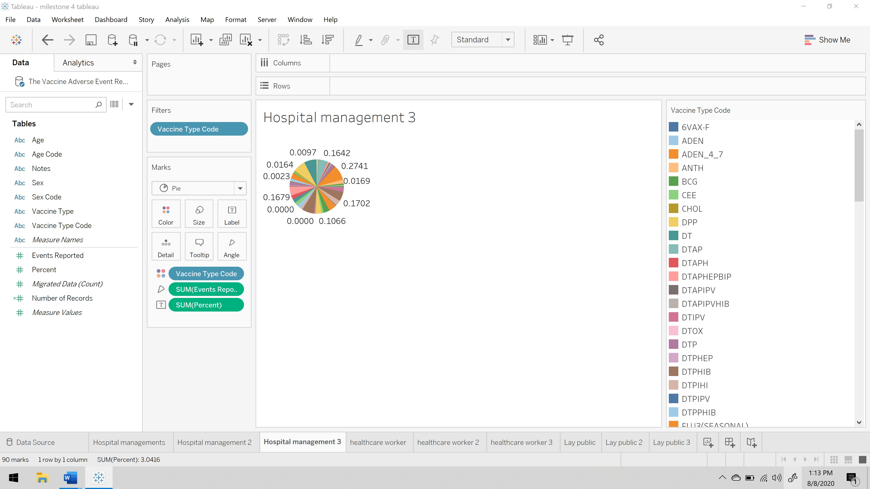

**For healthcare workers** interacting with families the main concentration of their story is to educate the patient for future side effects and talking through the facts based on the events reported in past. To enhancing the patient condition and preparing them for future as well. To address the selected audience, my analysis of representing data in stacked bars. This is an extended bar chart from looking at numeric values across one categorical variable to two. Each bar in a standard bar chart is divided into a few sub bars stacked on each categorical variable.

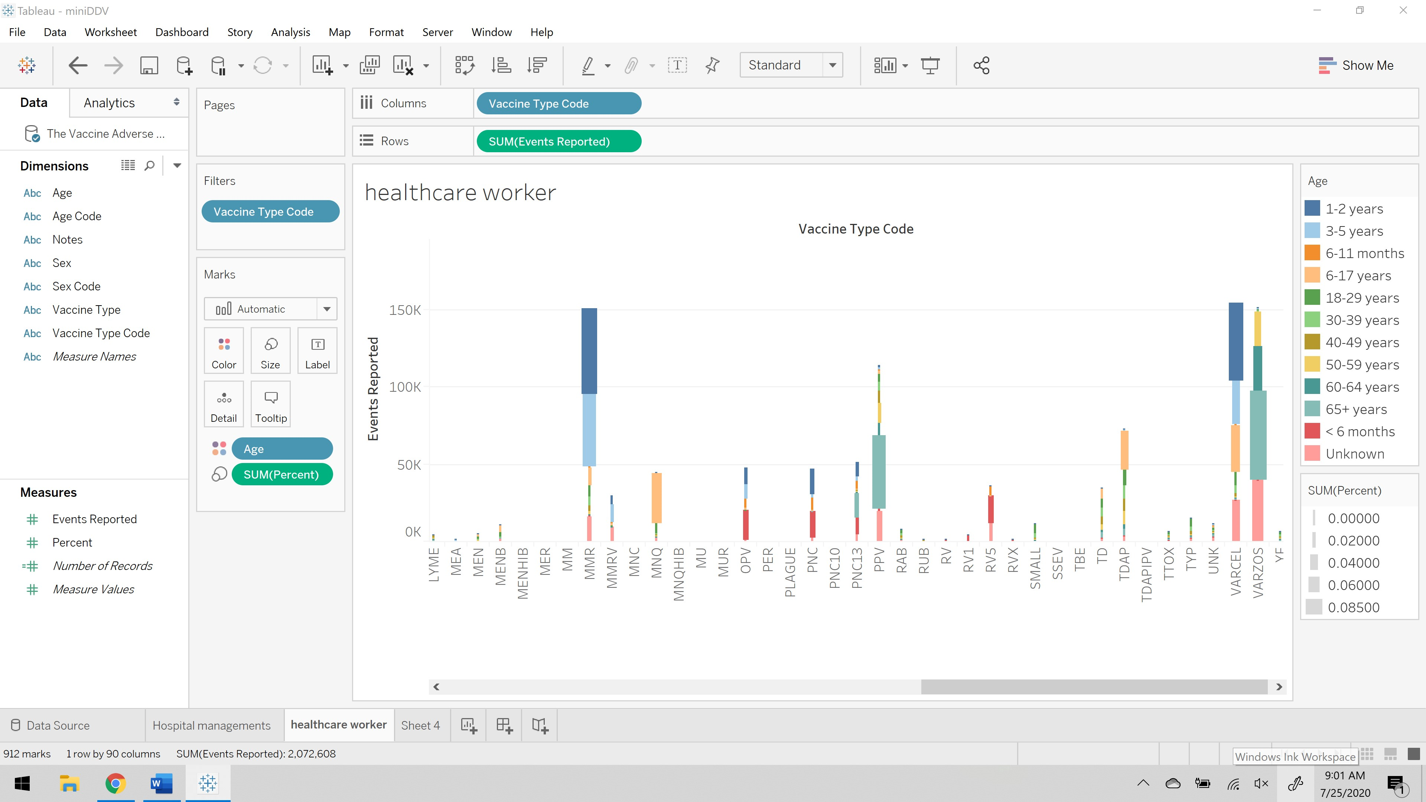

The above representation shows the color difference for age, the size of each bar is based on the risk percent, on x- axis there is vaccine type code and on y- axis there is events reported. This visualization gives us the information of how healthcare workers educate their patients regarding the vaccination and past events reported.

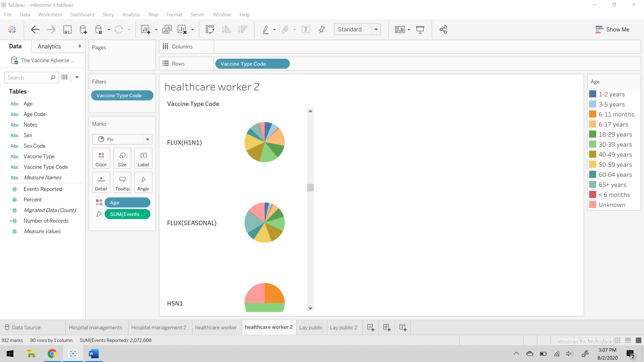

The above visualization is **for healthcare workers,** this visualization is presented by considering different visual cues and making this story to convey the data in most effective way. So, I have considered pie chart for each vaccine and that pie chart is divided by events reported by the patients and also the color tells us about the count of events reported by that particular age group to get better understanding of the future side effects of the patient at particular age group.

**For healthcare worker**, the below visualization is presented by choosing different visual cues and making that presentation understandable to the audience on column I have taken age, on rows I have considered events reported and on color visual cue I have consider vaccine type code. This gives the idea of the at what age which vaccines has reported highest cases.

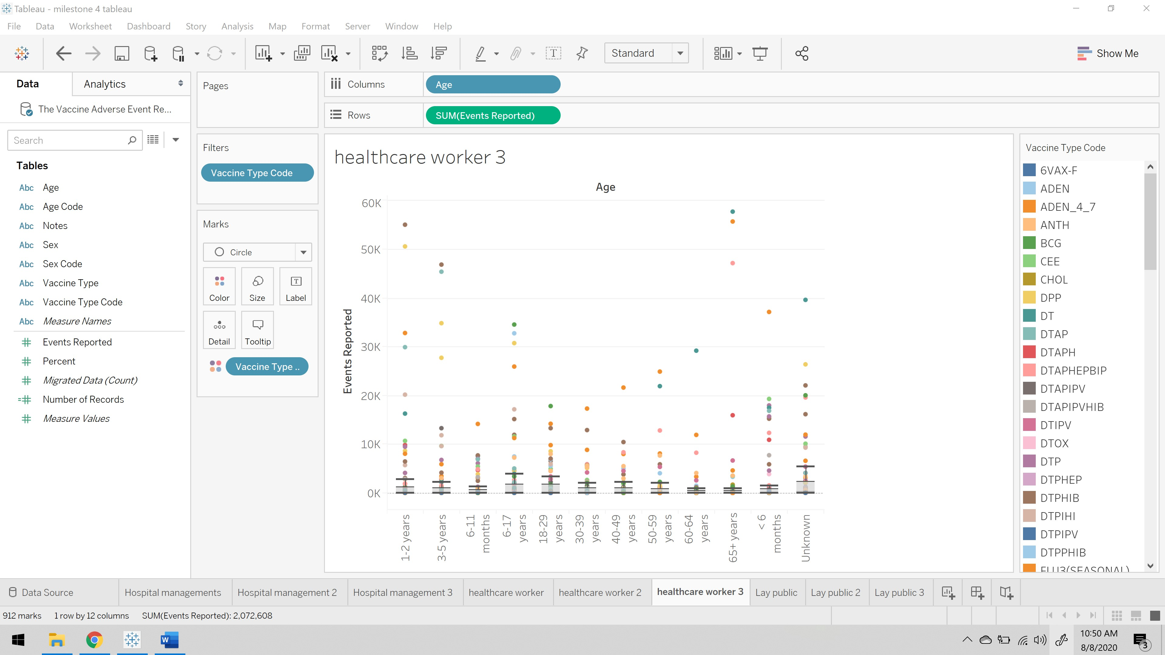

**For the lay public** audience are to be aware of what vaccination has highest risk percentage. Because the public just need to be aware of the vaccination that are available for the treatments if at all they need to have them what are the consequences. To address the selected audience, my analysis of representing data in Circle View chart. This is one of the powerful visualizations for comparative analysis.

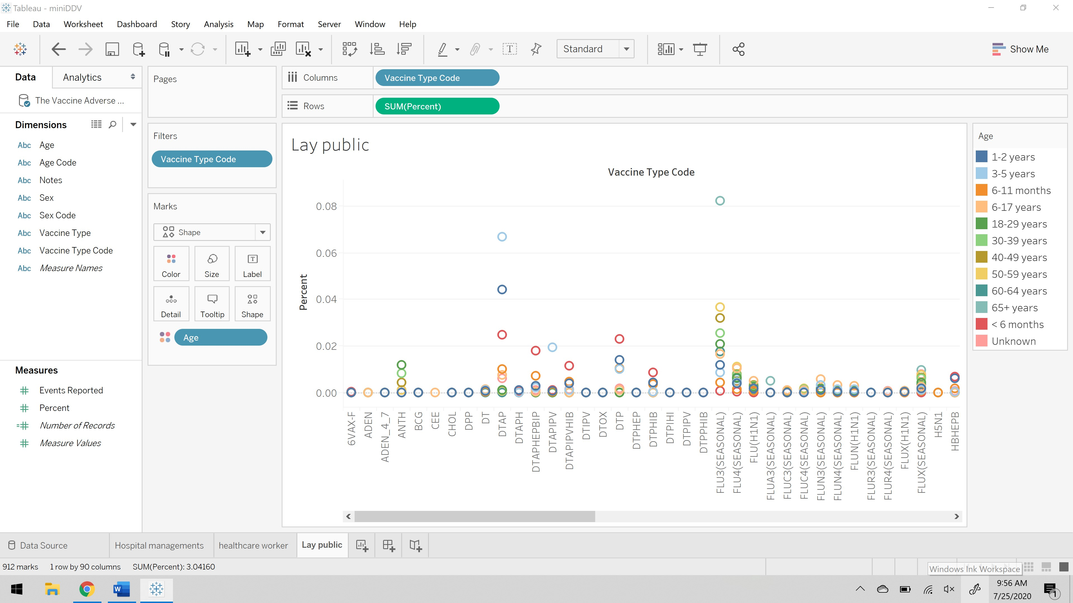

The above visualization shows the variation of color for age range, in x- axis there is list of vaccine type code, and in y- axis there is risk percentage. This visualization helps the public to figure out the what age group has the highest risk in taking that vaccine.

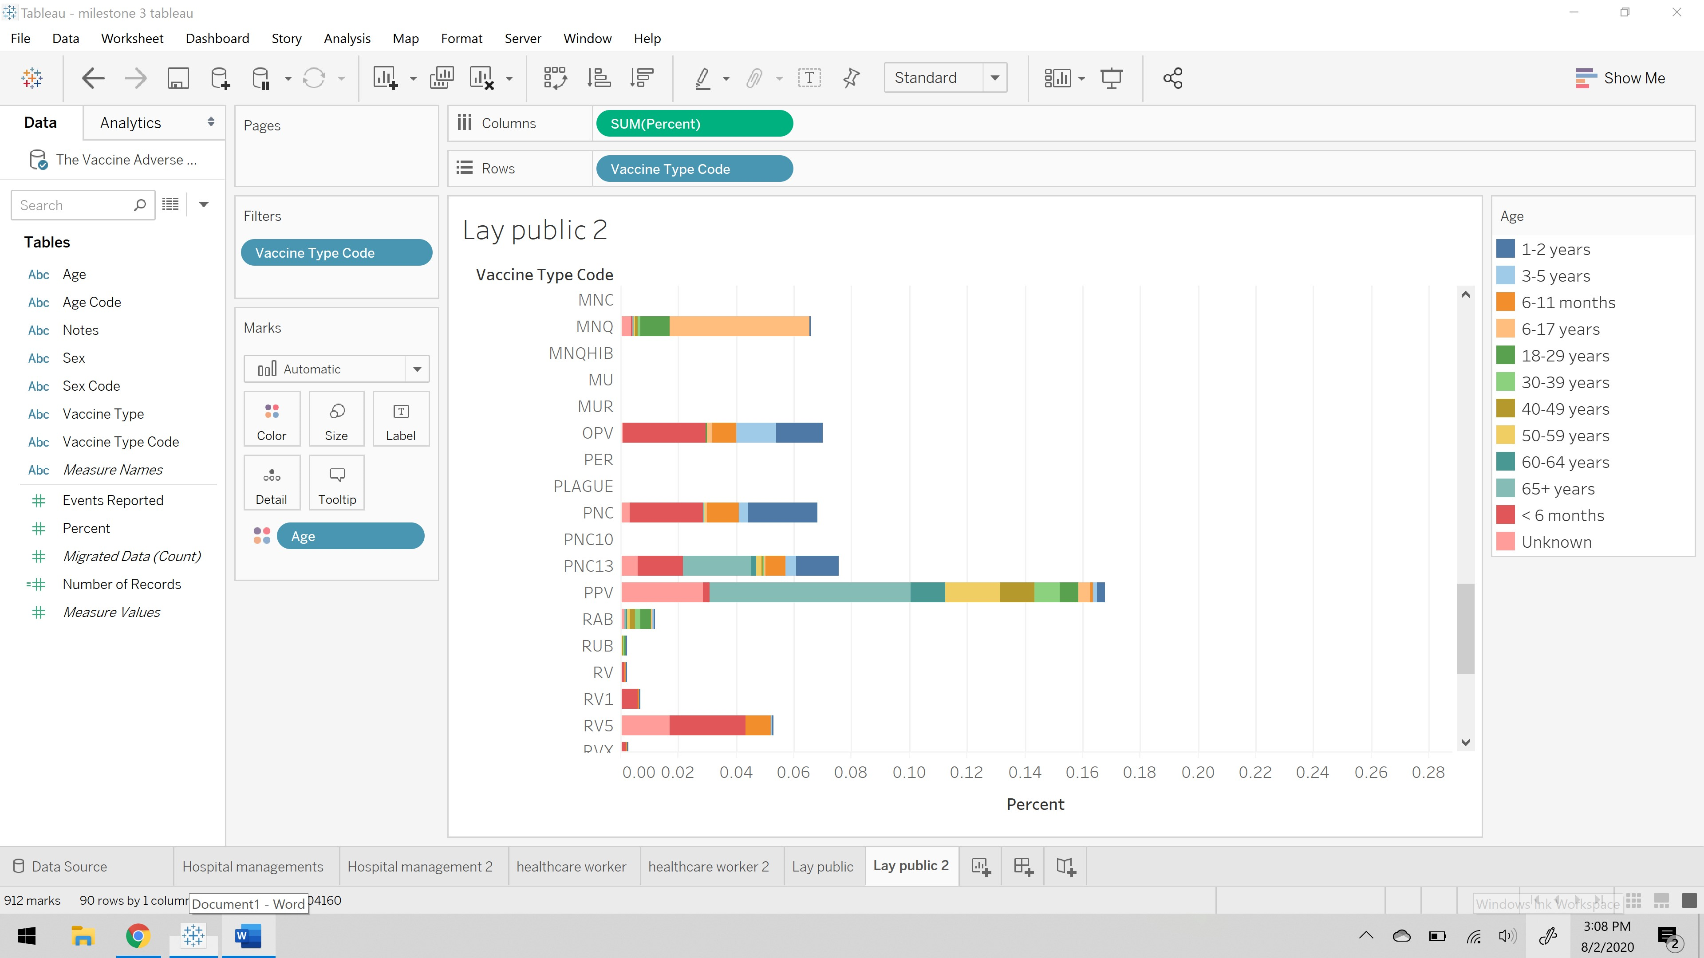

The above representation of the story explains the different approaches of the using visual cues to understand the data in better way possible. I have taken percent and vaccine type code on columns and rows respectively, with the age in color visual cue. This is telling the information about the which vaccine has the highest risk percent and for which age group.

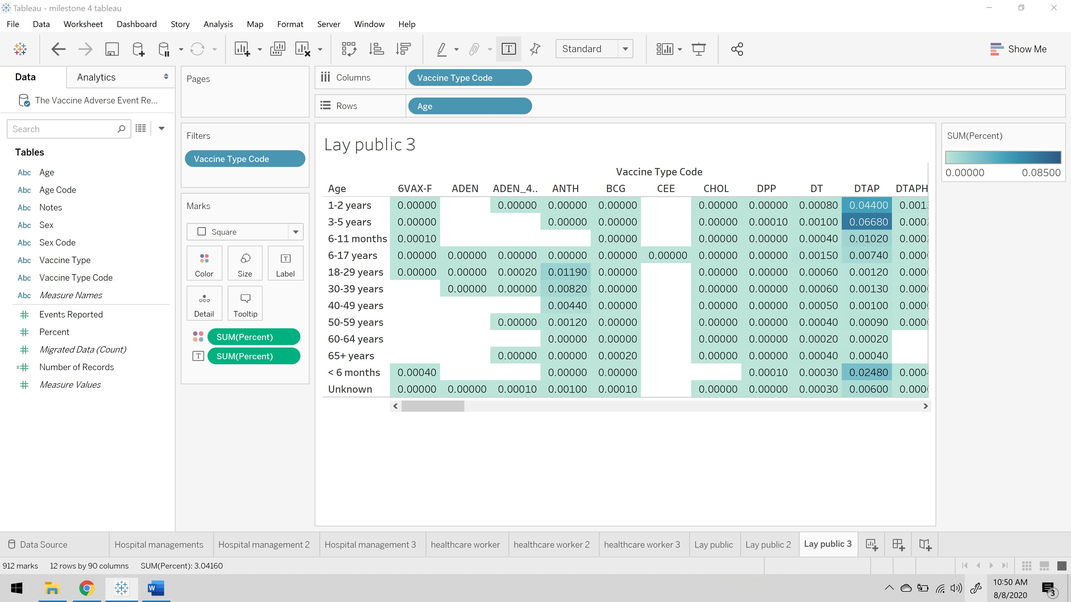

**For lay public** I have considered the above visualization to make audience understand the story clearly. To do so I have considered vaccine type code on columns, age on the rows, and risk percent on the color and label as well to make it clearer. This conveys what vaccine has reported more risk percent on what age group.

**Order of Presentation:**

I have chosen is initially hospital management’s perspective because total drugs or vaccines information will be received by the hospital management, next comes healthcare workers because doctors will choose what drug is required for certain patient and introduce them with the drug, and then finally come the lay public then public gets to know the drugs or vaccines work and success and risk rate. This is my order of presentation of different audiences.

**Effective Feedback Mechanism:**

A Feedback Loop is the part of a system in which some portion or all the system’s output is used for future operations. Each feedback loop has a minimum of four stages. During stage one, input is created. Next on stage two, input is captured and stored. Later, stage three, input is analyzed and finally in the fourth stage, the insight gained from analysis is used to make decisions.

This feedback mechanism is for all the three audiences that I have considered to visualize in the above presentation.

**Crafting a story:**

A lot of analysis is required to select how much and which content to be included in visualizing a data to present it to the audience. To do that the main goal is to shape a concise and coherent narrative around the data to compel the audience to take some sort of desired actions. To present the visualization we need to do the following steps:

1. **Creating an outline:** Identifying the tone of the visualization story that we need to convey to the audience. Selecting that data to support our point of view to make the audience understand the data that is presenting in the visualization.
2. **Arrange content in the most logical order:** Making the audience walk through the data in a logical flow. Each data visualization should help audience get closer to the narratives point of view.
3. **Provide context for the data:** Data visualization is meant to clarify, never confuse, or muddle. If there is a risk of misinterpretation, provide context to fill in the gaps.
4. **Highlight notable insights:** Although viewers can follow the data, key points may need more attention.
5. **Trim where necessary:** Do not overload with the data. Only include the data that is necessary and relevant to draw the audience towards the desired conclusion.

**Reference:**

1. <https://searchitchannel.techtarget.com/definition/feedback-loop#:~:text=A%20feedback%20loop%20is%20the,a%20minimum%20of%20four%20stages.>
2. <https://www.digiteum.com/data-visualization-techniques-tools>
3. <http://cdn2.hubspot.net/hub/53/file-2036439636-pdf/How_to_Use_Data_Visualization_to_Win_Over_Your_Audience.pdf>